**Java Lab Assignment**

**NAME : DEPANWITA DEY**

**ROLL NO. : 11200218041**

**STREAM : CSE (STREAM CHANGE)**

**SUBJECT: OBJECT ORIENTED PROGRAMMING**

**CODE: PCC-CS503**

**CLASS: 2ND YEAR SEMESTER: 4TH SEM GOVERNMENT COLLEGE OF ENGINEERING AND LEATHER TECHNOLOGY**

Modules Attempted :

1. Lab Unit 3
2. Lab Unit 12

Folder Structure:

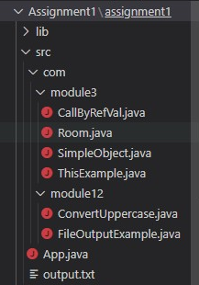

Here module3 and module12 are custom packages which are to be called and executed in App.java

**Lab Unit 3:**

1. **Write a program to create a room class, the attributes of this class is roomno, roomtype, roomarea and ACmachine. In this class the member functions are setdata and displaydata.**

**Solution**

**The Room class is in com.module3.Room.java.**

**CODE:**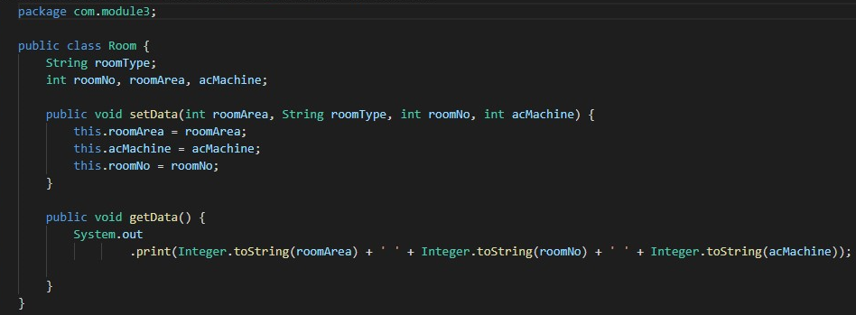

**App.java:**

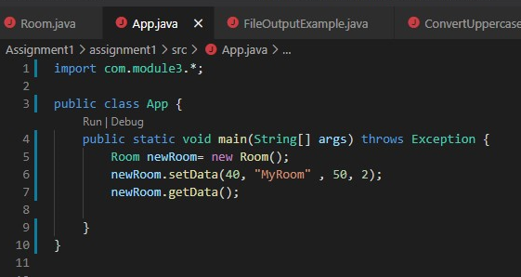

**OUTPUT:**

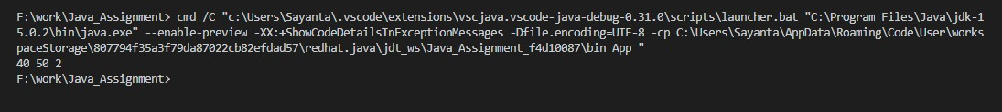

1. **Write a program create a class simpleobject. Using constructor display the message.**

**The simpleobject class is in com.module3.SimpleObject**

**CODE:**

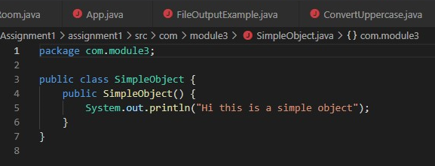

**App.java:**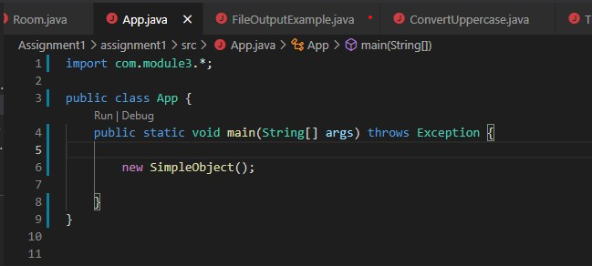

**OUTPUT**:



1. **Write a program for the following**

**1. Example for call by value.**

**2. Example for call by reference.**

**CODE:**

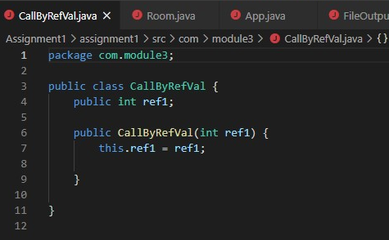

**App.java:**

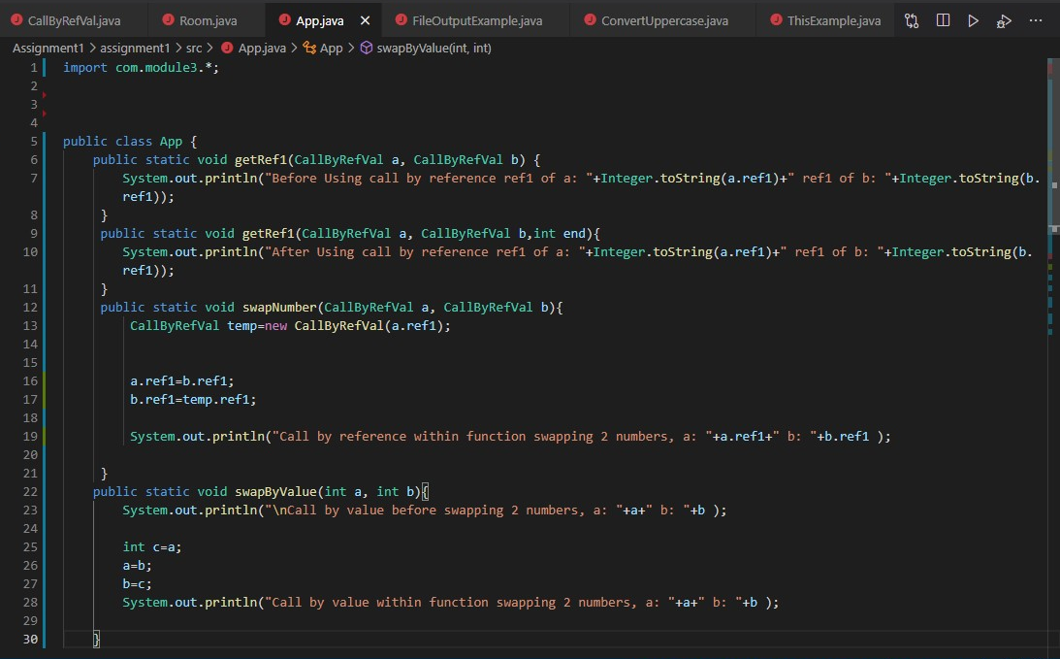

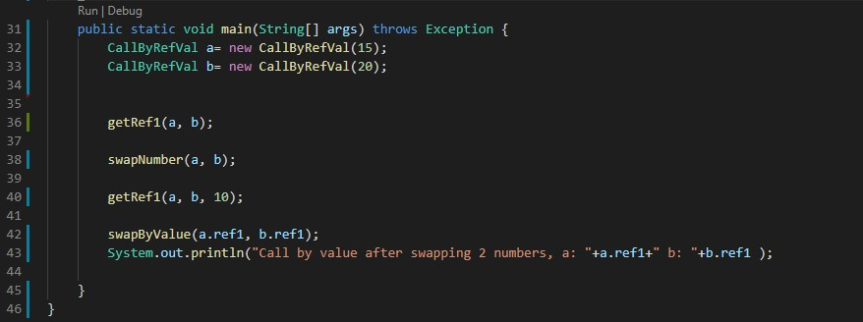

**OUTPUT:**

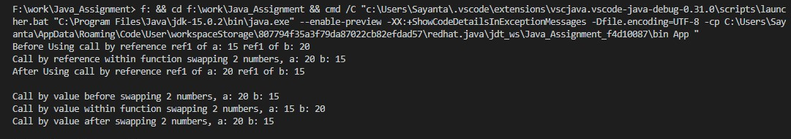

1. **Write a program to give the example for this operator. And also use the this keyword as return statement.**

**CODE:**

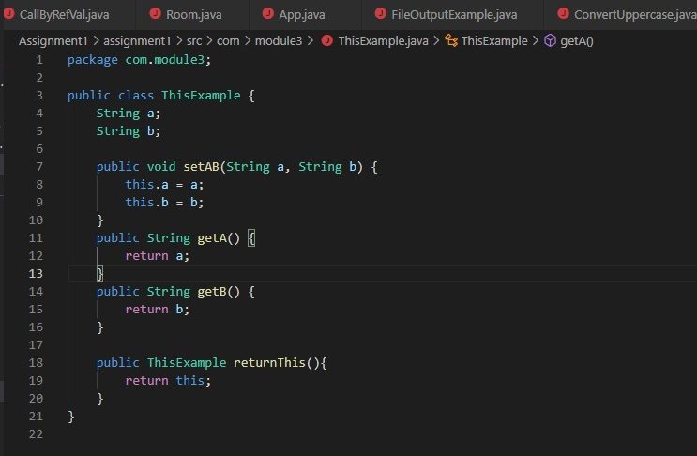

**App.java:**

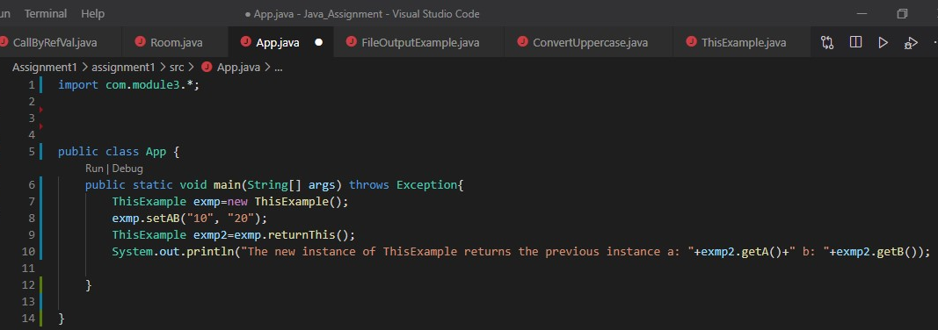

**Output:**

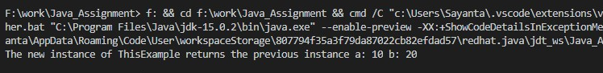

**Lab Unit 12:**

1. **Write a program to create a file and write data into it using the methods OutputStream class.**

**CODE:**

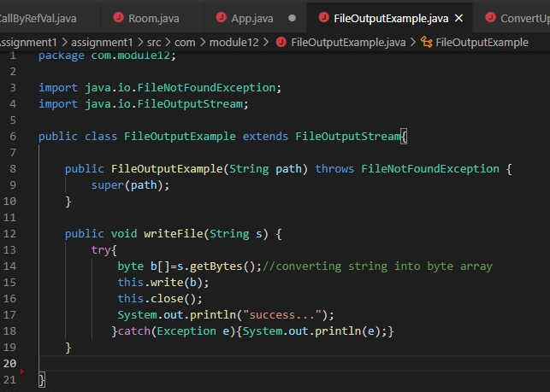

**App.java:**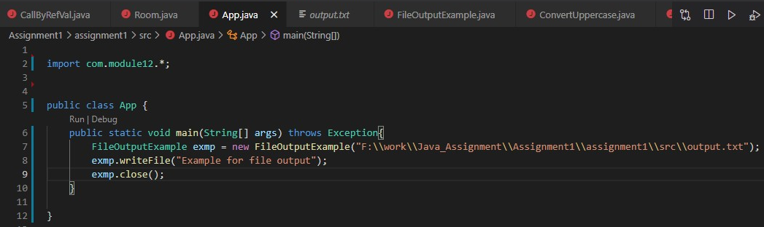

**OUTPUT:**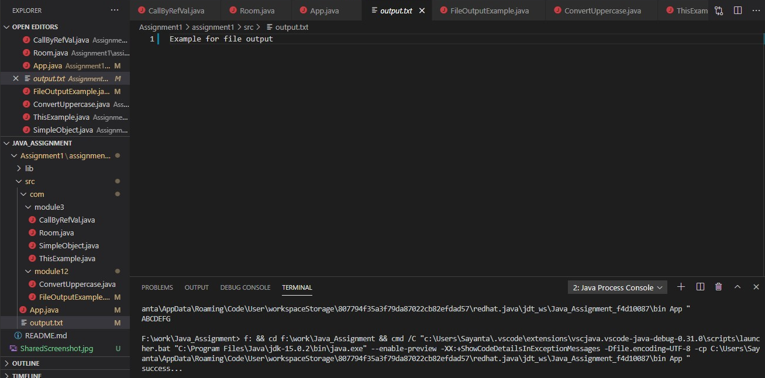

1. **Write a program to accept specified number of characters as input and converts them into uppercase characters.**

**CODE:**

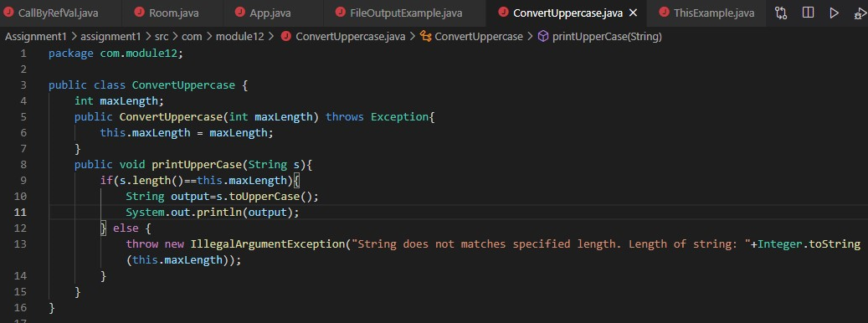

**When string does not match**

**App.java**

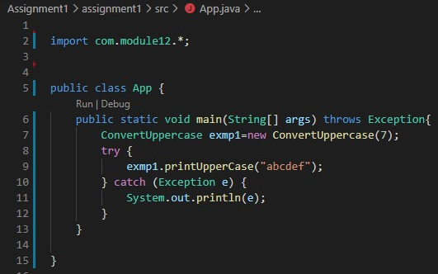

**Output:**

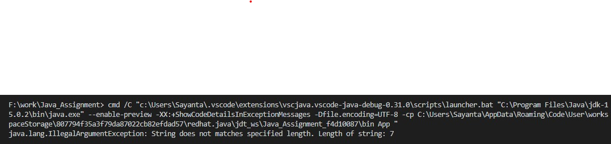

**When string match:**

**App.java:**

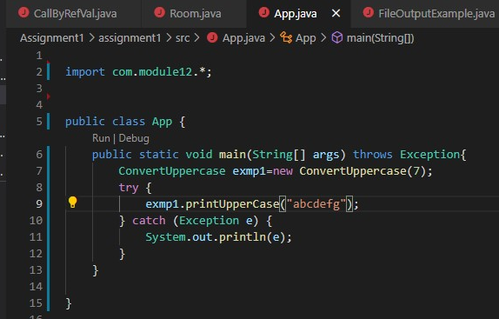

**Output:**



1. **Write a program to get the input from the user and store it into file. Using Reader and Writer file.**

**CODE:**



**App.java:**

**OUTPUT:**